PRACTICAL – 9
Project no:16 | Write off of computational items

AIM: Implementation of at least five different SQL nested sub queries in from clause on each Banking- University and Project assigned

Theory: In SQL, nested subqueries in the FROM clause are powerful tools that allow complex data manipulations by treating the results of a subquery as a temporary table or "derived table" that can be queried further. This approach is essential for scenarios where data needs to be pre-processed or restructured before applying additional operations, such as filtering, aggregation, or joining with other tables.

The FROM clause subquery enables breaking down complex queries into manageable steps. Instead of performing all calculations or transformations in a single large query, nested subqueries modularize the process. For instance, one subquery can calculate aggregated data (like averages, sums, or counts) or filter a subset of rows based on specific criteria. The main query can then focus on processing this precomputed data without reapplying the same operations.

One of the key advantages of this approach is improved readability and maintainability of the query. When working with large datasets, nested subqueries also enhance query optimization by isolating specific computations, reducing the processing burden on the database engine. They are particularly useful in scenarios requiring repeated aggregations, complex joins, or multi-step calculations.

For example, in a banking scenario, a nested subquery can calculate the total balance per account type, which is then used in the main query to identify account types exceeding a threshold. In a university database, subqueries might filter students achieving specific grades and aggregate data for those students. Similarly, in project management, subqueries can identify projects assigned to certain departments and compute the overall progress for analysis.

In summary, nested subqueries in the FROM clause offer a structured and efficient way to handle complex queries by creating intermediate, derived datasets. This approach enhances clarity, reusability, and performance, making it a fundamental feature of SQL for handling real-world data analysis challenges.

STEPS : a) BANKING DATABASE

QUERY 1 : Find accounts with balances greater than the average balance of all accounts

SELECT account_number, branch_name, balance
FROM (
SELECT account_number, branch_name, balance
FROM account
) AS account_data
WHERE balance > (
SELECT AVG(balance)
FROM account
);

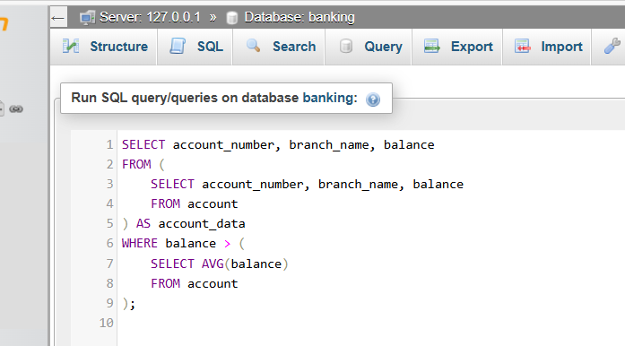

RESULT

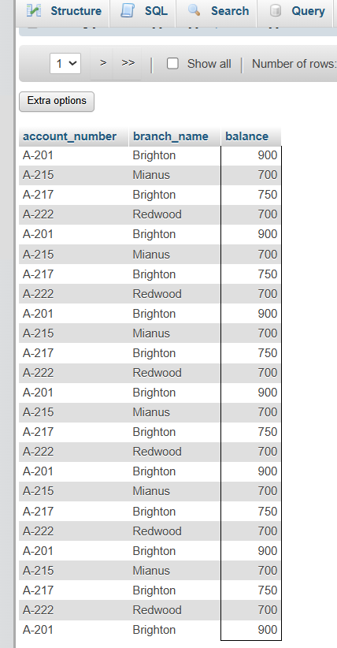

QUERY 2 : Find customers who have taken loans from a branch located in 'Brooklyn'

SELECT customer_name, loan_number
FROM (
SELECT customer_name, loan_number
FROM borrower
) AS borrower_data
WHERE loan_number IN (
SELECT branch_name
FROM branch
WHERE branch_city = ‘Brooklyn’
);

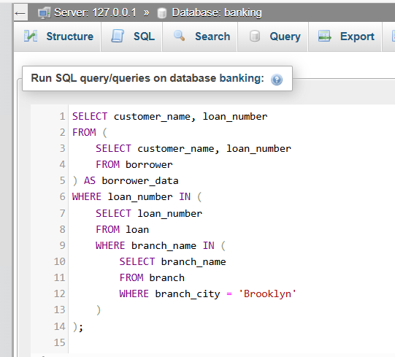

RESULT

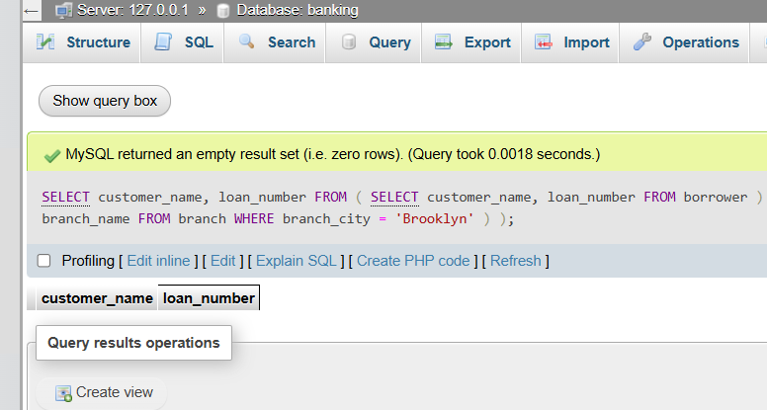

QUERY 3 Find branches where the total assets are greater than the average branch assets

SELECT branch_name, assets
FROM (
SELECT branch_name, assets
FROM branch
) AS branch_data
WHERE assets > (
SELECT AVG(assets)
FROM branch
);

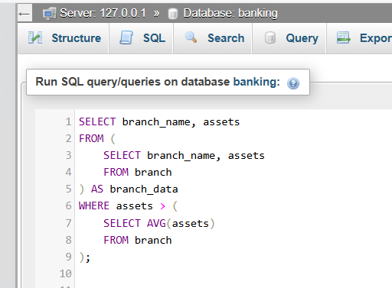

RESULT

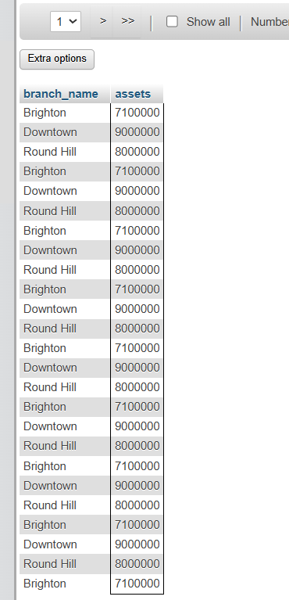

QUERY 4 : Find customers who have both an account and a loan
SELECT customer_name
FROM (
SELECT customer_name
FROM depositor
) AS depositor_data
WHERE customer_name IN (
SELECT customer_name
FROM borrower
);

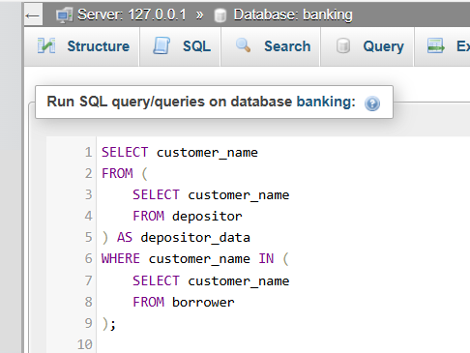

RESULT

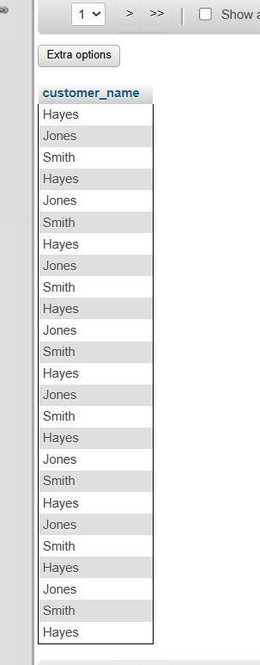

QUERY 5 : Find branches that have at least one account with a balance greater than 600
SELECT branch_name
FROM (
SELECT branch_name
FROM account
) AS account _data
WHERE branch_name IN (
SELECT branch_name
FROM account
Where balance > 600
);

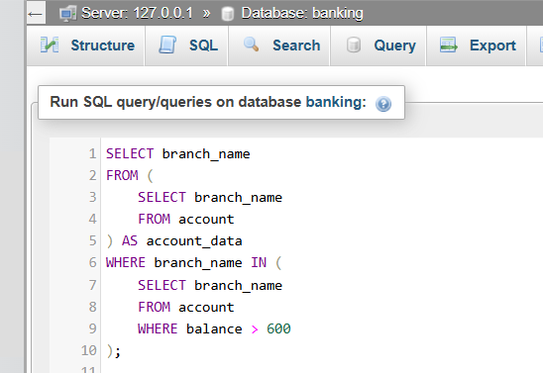

RESULT

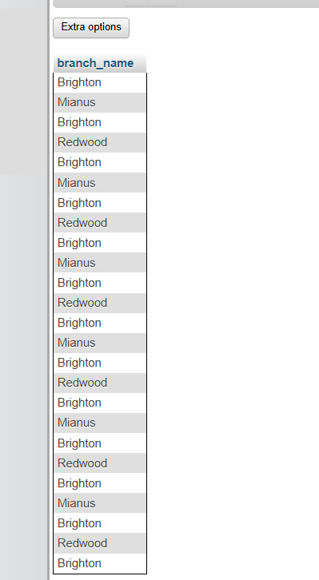

b) UNIVERSITY DATABASE

QUERY 1 : List instructors with their department’s average salary

SELECT I.name, I.salary, D,avg_salary
FROM (
SELECT dept_name, AVG(salary) AS avg_salary
FROM account
) AS account _data
WHERE branch_name IN (
SELECT branch_name
FROM account
Where balance > 600
);

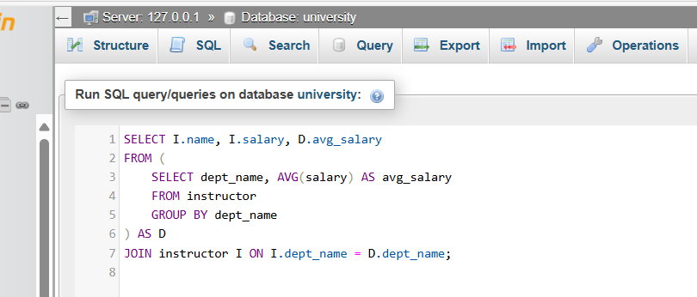

RESULT

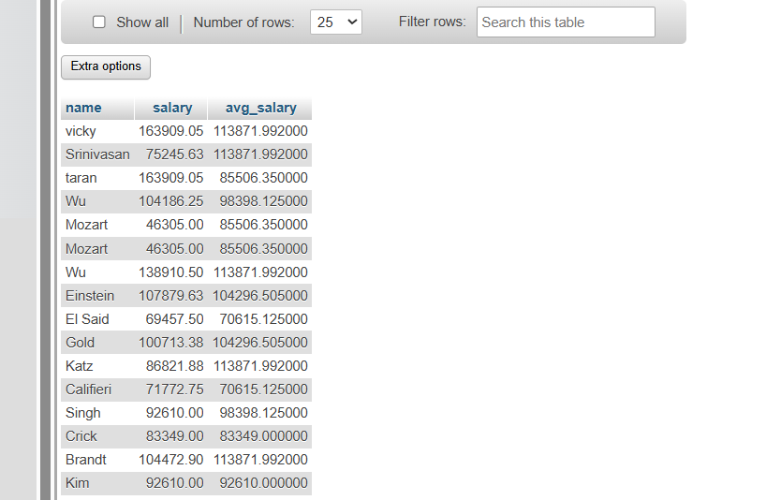

QUERY 2 : List courses from departments with instructors earning above 80,000

SELECT C.title, C.dept_name
FROM (
SELECT dept_name FROM instructor WHERE salary > 80000
) AS high_salary_depts
JOIN course C ON C.dept_name = high_salary_depts.dept_name;

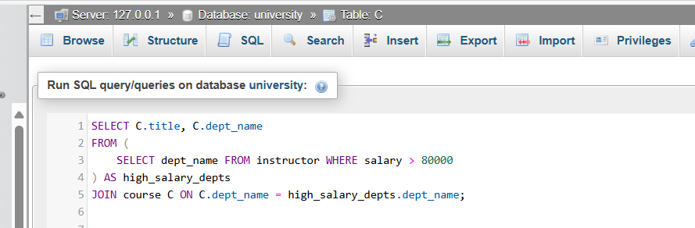

RESULT

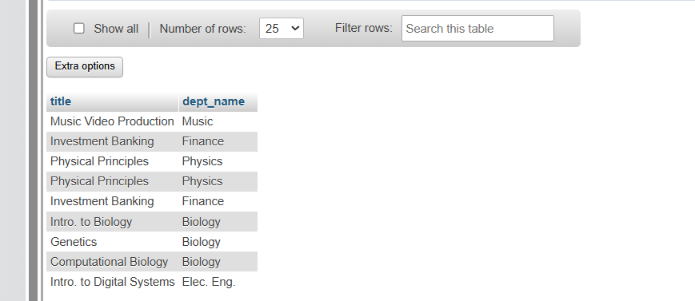

QUERY 3 : Find advisors advising multiple students

SELECT I.name AS advisor_name, student_count.count_students
FROM (
SELECT i_ID, COUNT(s_ID) AS count_students
FROM advisor
GROUP BY i_ID
) AS student_count
JOIN instructor I ON student_count.i_ID = I_ID
WHERE student_count.count_students > 1

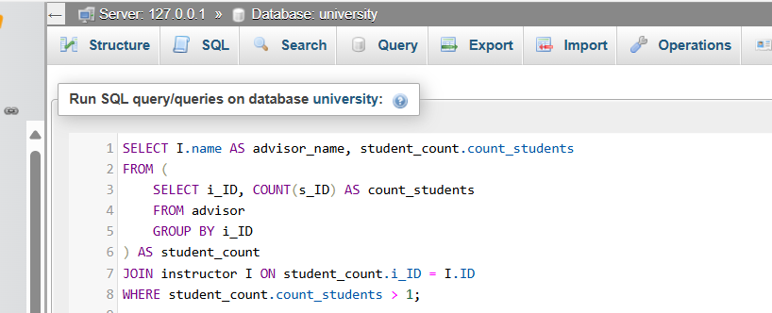

RESULT

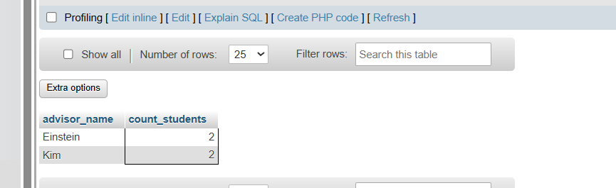

QUERY 4 : List courses offered by departments where the max instructor salary exceeds 90,000

SELECT C.title, C.dept_name
FROM (
SELECT dept_name, MAX(salary) AS max_salary
FROM instructor
GROUP BY dept_name
) AS max_salaries
JOIN course C ON C.dept_name = max_salaries.dept_name
WHERE max_salaries. max_salary > 90000;

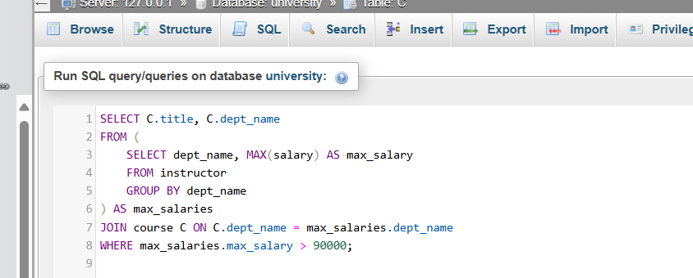

RESULT

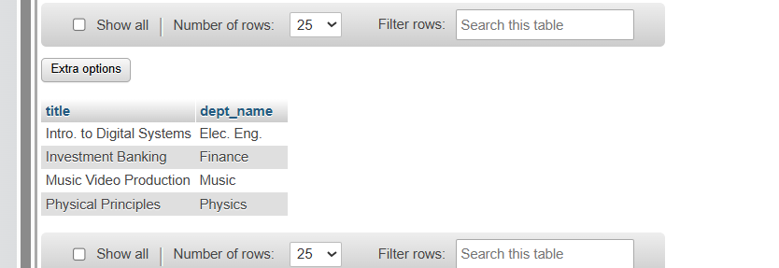

QUERY 5 : Find the maximum salary by department and list courses from those departments

SELECT C.title, C.dept_name, max_salaries. max_salary
FROM (
SELECT dept_name, MAX(salary) AS max_salary
FROM instructor
GROUP BY dept_name
) AS max_salaries
JOIN course C ON C.dept_name = max_salaries.dept_name

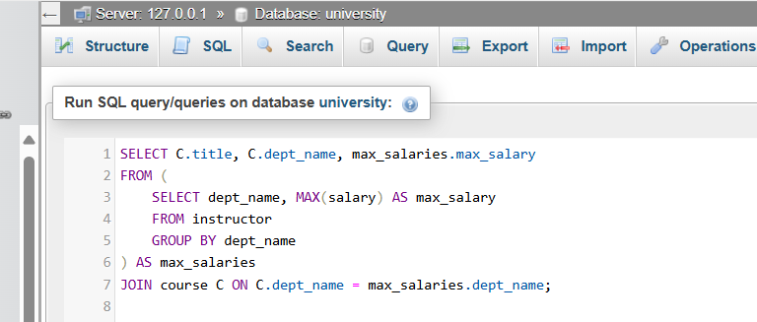

RESULT
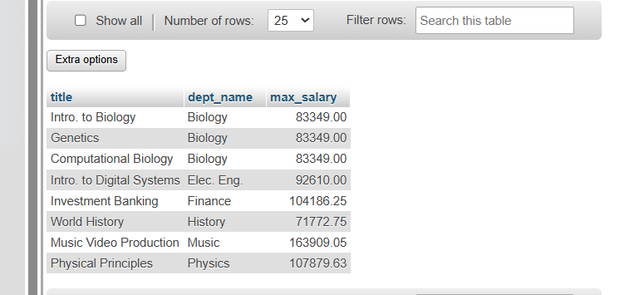

c) Project: 16

QUERY 1 :

Find All Staff from CSE Branch
SELECT firstName
FROM (
SELECT firstName, DEPARTMENT
FROM faculty_data
WHERE DEPARTMENT = 'CSE'
) AS cse_faculty;
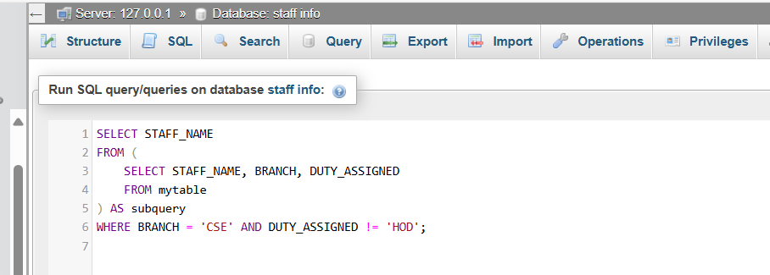

RESULT
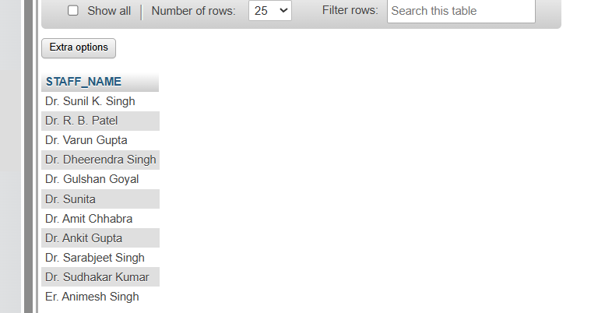

QUERY 2 : Staff in CSE with last name Singh
SELECT firstName
FROM (
SELECT firstName, lastName, DEPARTMENT
FROM faculty_data
WHERE lastName = 'Singh'
) AS singh_faculty
WHERE DEPARTMENT = 'CSE';
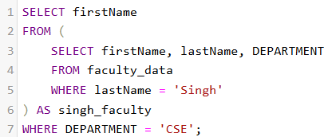

RESULT
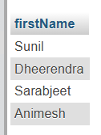

QUERY 3: Extract faculty names based on printer refill date criteria.
SELECT firstName
FROM (
SELECT firstName, Date_of_last_refil
FROM printer_issue_detail
WHERE STR_TO_DATE(Date_of_last_refil, '%d-%m-%Y') > '2023-01-01'
) AS recent_refills;

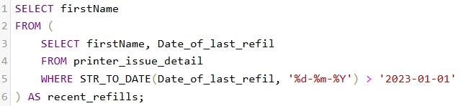

RESULT
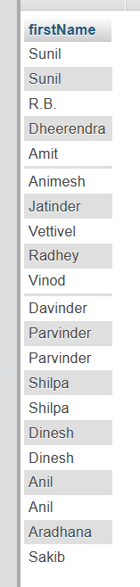

QUERY 4 : Identify faculty members assigned specific printer models.
SELECT firstName
FROM (
SELECT firstName, Printer_model
FROM printer_issue_detail
WHERE Printer_model = 'Brother_7500D'
) AS specific_printers;
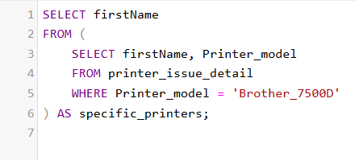

RESULT


QUERY 5 : Combine Designation and Printer_model filters to refine data.
SELECT DISTINCT firstName
FROM (
SELECT firstName, Designation, Printer_model
FROM printer_issue_detail
WHERE Designation = 'Professor' AND Printer_model LIKE 'canon%'
) AS professor_printers;
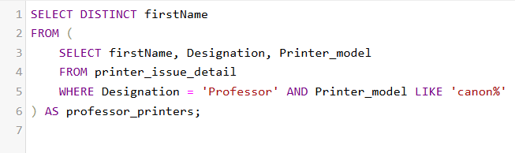

RESULT
